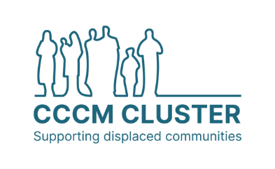

CCCM Cluster Response Strategy

Key information

Country | [Delete rows as appropriate]
Crisis response name
Cluster / Sector lead agency
Co-leads/Co-Coordinators
Strategic Advisory Group (SAG) - Agencies
Technical Working Groups (TWG) - Agencies | - [if applicable]

Strategy Status

Endorsed by cluster | Effective date | Next revision
Yes/No | day / month / year | day / month / year

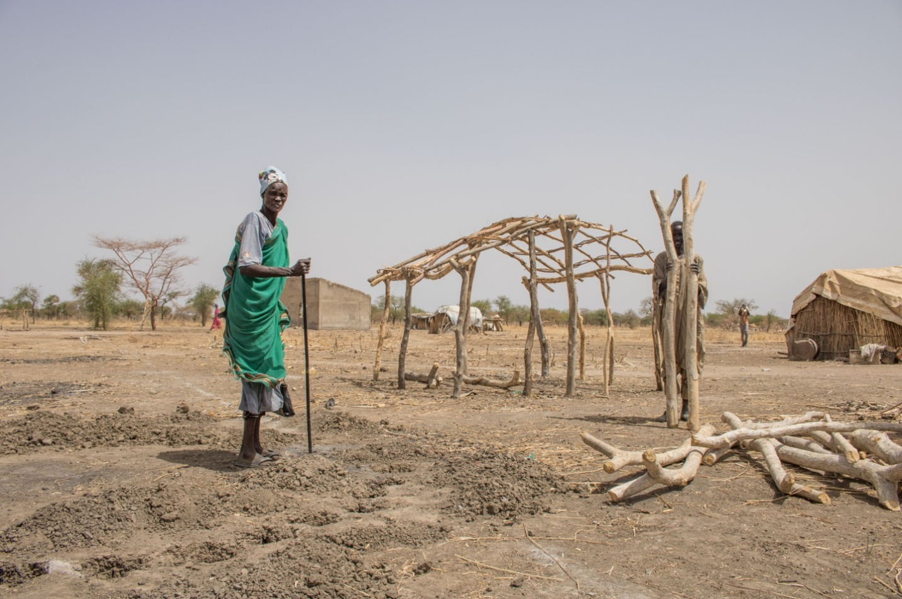
Insert image

Note to help with drafting [delete]: The CCCM Cluster Response Strategy outlines the collective CCCM response to be undertaken. It should be the output of a process of strategy development in consultation with Cluster members and other stakeholders: see CCCM Cluster Coordination Toolkit Section 4. Strategic Planning – Strategy Development for guidance. The Response Strategy provides an overarching framework and a vision for the CCCM response, and guidance on prioritisation of activities that are relevant throughout the implementation period. It should be complemented by a cluster coordination team Workplan, detailing the specific work that the coordination team will conduct to support the operational CCCM response in line with the 6+1 core functions of clusters.

Context, risks, and needs analysis

Include here:
- Short background in the country and/or region of concern (displacement context; political, economic, security concerns; other threats and hazards)
- Situation and needs analysis summarizing findings of assessments, CCCM needs, and capacities (available affected population figures; displacement site typologies; geographic areas affected; humanitarian situation and needs relating to CCCM). Mention sources / refer to HNO.
- Relevant government policies and objectives
- Government roles and responsibilities in relation to CCCM activities
- General humanitarian situation and humanitarian response priorities. Plus, any ongoing CCCM response. Include reference to the overarching humanitarian priorities / HRP strategic objectives (1-2 sentences) & HCT key protection priorities / risks (1-2 sentences).

CCCM Response

Include here:
- Overall objective – the overall goal for CCCM as a sector or cluster (in coherence with the Humanitarian Country Team (HCT) strategic & protection priorities and policies)
- If necessary, description of the rationale that links the needs described in the situation analysis and the planned CCCM response
- Description of the planned CCCM activities, and their expected outputs and impact (expand on the activities listed in the Response Framework in Annex 1)
- Linkages with other clusters’ or sectors’ responses, and how the cluster/sector contributes to the overall humanitarian response strategy
- How the CCCM response will address, mitigate and prevent critical protection risks or threats identified as priorities by the HC/HCT in their protection strategy and/or HRP centrality of protection strategic objectives, and in any Protection Risk Analysis conducted as part of the CCCM Cluster Response Strategy development.
TIP: be concise and use accessible language! The strategy should be easily understood and aim to be a useable document for CCCM stakeholders. Diagrams and tables can be useful to communicate information without using a lot of text.

Title…

Additional sections can be added – or not – as needed, if the Cluster/Sector plans to have substantial focus on a specific topic as part of the response strategy. Examples that might require an additional section could be:
- Contingency planning
- Work towards durable solutions or exit strategy
- Advocacy

Cross-cutting issues

Outline how you will consider cross-cutting issues in the CCCM response. These should be discussed with Cluster members as part of the strategy planning process (remembering that this document is the output, or end product, of a process). Focus on how Cluster members, and the Cluster coordination team, collectively commit to meaningfully addressing these in the CCCM response. Refer to the CCCM Cluster Coordination Toolkit section on Cross-cutting Issues for further guidance, and links to Tipsheets for including specific issues in strategic planning processes.

Cross-cutting issues that you should consider include:

- Localization*
- Disability
- Age, gender and diversity
- GBV
- Child Protection
- Environment
- Protection mainstreaming and centrality of protection
- MHPSS

Accountability to Affected Populations

Include here:

- How delivery of CCCM activities will aim to be accountable to the communities receiving assistance
- How the overall CCCM response will aim to be accountable to affected communities
- Any specific accountability efforts being planned as part of the CCCM response

Monitoring plan

Include here:
- How the planned response will be monitored (e.g. (e.g. CCCM Cluster 3W, monthly partner reporting within or in addition to the HRP response monitoring framework, etc.)
- What else will be monitored and how (e.g. conditions in displacement sites, incidents in sites)
- What products or datasets the Cluster will produce based on monitoring data, and when
- How monitoring information collected will be used to adjust or improve the CCCM response
This section complements the Response Framework (Logframe) in Annex 2, which includes the indicators selected to monitor CCCM activities. The response monitoring plan should take into account the Cluster’s HRP reporting requirements, where one is in place. Consider how to adopt a participatory approach for the monitoring of the strategy, through consultation with affected people.
TIP: Consider using visual presentation of information rather than text. E.g. presenting the monitoring plan as a table showing actions, who is responsible, and timeframes. A flow chart can be a useful visual aid, to demonstrate information flowing both ways between CCCM partners and the Cluster (and intersectoral coordination / OCHA).

Annex 1. CCCM Response Framework (Logframe)

Include here:
- Response framework (simple logframe) summarising the overall objective of the CCCM response, specific objectives, planned activities, and indicators chosen to monitor response delivery
- Table should support the Monitoring section of the Response Strategy
- Where an HRP or other humanitarian response plan is in place, this section should reflect the CCCM response monitoring framework developed for the HRP
See Toolkit Section 6. Response monitoring and reporting for guidance on developing a response framework / logframe.

TIP: Adjust the table as relevant for your context. Indicators should be SMART (Specific + Measurable + Achievable + Realistic + Time-bound) and be useful – and used – for the actual monitoring of the response when data is collected.

Overall objective: |  | Text
Specific objectives | Activities |  | Sub-activities (if relevant) | Indicator [recommended for activity or specific objective-level not sub-activity level, to minimise reporting requirements] | Target | Means of verification (Data source) | Assumptions or risks
Specific objective 1 | Activity 1 |  | Sub-activity a | Text | XXX | e.g. monthly partner report
 |  |  | Sub-activity b | Text | XXX | Text
 | Activity 2 |  |  | Text | XXX | Text
Specific Objective 2 | Activity 3 |  |  | Text | XXX | Text
… | … |  | … | … | … | …

Annex 2. Maps

Insert map, if any

