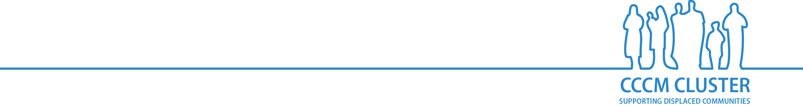**MSCM DISABILITY INCLUSION CHECKLIST**

**COMMUNITY PARTICIPATION AND REPRESENTATION**

***Community participation***

* Are persons with disabilities included in participation methodologies set up by the SMA? Has a budget been allocated to support their engagement?
* Are persons with disabilities involved in each stage of the project cycle – assessment, planning, implementation, monitoring and evaluation?
* Are there diverse accessible channels for persons with disabilities to reach out to the site management team and report on their views and concerns?
* Do persons with disabilities report to be satisfied with the opportunities they have to influence site decisions?
* Do women with disabilities feel their views are considered in decision-making processes?

***Information sharing and communication***

* Have persons with different types of disabilities been consulted on their communication needs and preferences?
* Is key information, education and communication material provided in multiple formats and mediums in the site (such as large print, easy read and jargon free, pictograms, sign language, oral, radio, videos, text messages)?
* Is information disseminated in multiple accessible locations (such as at information desks, distribution sites, safe spaces and health facilities; during site committee meetings and focus groups; via door-to-door visits and community mobilisers)?
* Is monitoring organized to ensure that persons with different types of disabilities are included and have access to key information about the site’s life, overall services and assistance available, as well as on specific services that concern them?

***Feedback and complaints***

* Can feedback and complaints be collected through a variety of channels (such as verbal, written, electronic, paper-based, boxes, help desks, hotlines), in accessible ways and locations?
* Are feedback and complaints mechanisms accessible to people who stay in their shelters?
* When taking actions and reporting back, is accessibility also considered?
* Is there a way to monitor the use of feedback and complaints mechanisms by persons with disabilities (for example, is data disaggregated by sex, age and disability using the Washington Group Short Set of Questions)?
* Can disability-specific complaints be also collected through these mechanisms – e.g. on accessibility, inappropriate (or denial of) reasonable accommodation? Are answers provided in a timely, accessible and knowledgeable way?
* Are prevention of sexual exploitation and abuse mechanisms accessible to persons with disabilities?

***Governance structures***

* Are there active organizations of persons with disabilities, self-support groups or community disability committees in the site or surrounding communities? If so, are they representative of the site population in its diversity (sex, age, ethnicity, disabilities)?
* Are persons with disabilities and/or their representative organizations involved in site governance structures or groups? Do they play a meaningful role? Are the persons/entities involved representative of the population in terms of sex, age, ethnicity and disability? Do persons with disabilities feel they are represented by and through the site governance structure?
* Have barriers and enablers to participation of persons with disabilities been identified? Have persons with disabilities been involved in their identification? Do barriers and enablers assessments take place on a regular basis?
* Has a risk assessment been conducted, keeping in mind the “do no harm” principle, on the participation of persons with disabilities and the potential impact on their life and the way they are perceived? Are risk assessments conducted on a regular basis?
* Have trainings been organized by the SMA or partners for persons with disabilities, their families and organizations of persons with disabilities to ensure their meaningful participation and increased resilience?