**Camp Departure Follow Up Survey | Process flow & overview**

**CCCM Cluster – Protection Cluster – Iraq Information Centre**

As of March 2021

**Overview**

* The objective is to assess the overall situation of families departing from camps and identify needs in their destination.
* Joint initiative of the CCCM Cluster, Protection Cluster, and the Iraq Information Centre (IIC, a humanitarian call centre).
* Initially set up in September 2019 to provide more information on the immediate situation of families who left camps. Calls then conducted on a rolling basis.
* Simple multi-sector questionnaire developed & input to by the other Clusters.
* Upscaled in late 2020, in response to sudden camp closures in federal Iraq during which time 16 camps and informal sites were suddenly closed or reclassified, with many families evicted.
  + Intended to **inform** response planning + provide **referrals** to assistance
* 33 rounds of calls were conducted, calling 5,900 households. For camp closures from October 2020 to January 2021, 4,070 households were called (38% of all households who departed camps). During the camp closures, two NGOs conducted the follow-up calls for families from camps they managed before closure, to speed up call rate and data availability.
* Survey was stopped in February 2021 after the last of the Camp Closure calls, due to limited uptake of the data for operational and planning purposes (see limitations, below)

**Process flow**

The Camp Departure Follow-Up Survey utilizes data already available from a Camp Exit Survey.

The camp **Exit Survey** is a simple tool is used by each Camp Management agency to record intended destination of families leaving from the camps. The tool was standardized by CCCM partners within the Cluster and is hosted on a central Kobo tool server by the CCCM Cluster. Data is then extracted and shared back to each individual camp management agency on a regular basis. The Cluster conducts anonymized aggregate analysis periodically on departure trends

* **EXIT SURVEY:** as families leave a camp
  + Asked by Camp Management to each family as part of the exit process from the camp
  + Questionnaire content:
    - Intended destination: governorate/district/sub-district/village-neighborhood
    - Date of departure
    - Name, contact details, & consent to be contacted by humanitarian actors
  + CCCM Cluster hosts the central Kobo tool. Cluster shares:
    - Full dataset back with Camp Management agencies
    - Names & contact details of consenting families with the IIC
* **FOLLOW-UP SURVEY:** 2+ weeks after families’ departure from a camp
  + Conducted by phone by the IIC, at least 2 weeks after a family has departed a camp
  + Questionnaire content:
    - Current location: governorate/district/sub-district/village-neighborhood
    - Multi-sector basic information, including: intentions, shelter type & damage, civil documentation, feeling of safety, risk of eviction, access to WASH, access to food, access to income, disabilities & health concerns, priority needs
    - Contact details & permission for onward referral to humanitarian actors
  + IIC shares the dataset shared back to CCCM Cluster, for analysis & below products

|  |  |
| --- | --- |
| Exit Survey Tool | Camp Departure Follow-Up Survey Tool |
|  |  |

**Products & datasets**

The following were produced and shared:

1. **Dashboards** [public] giving overview analysis
   1. 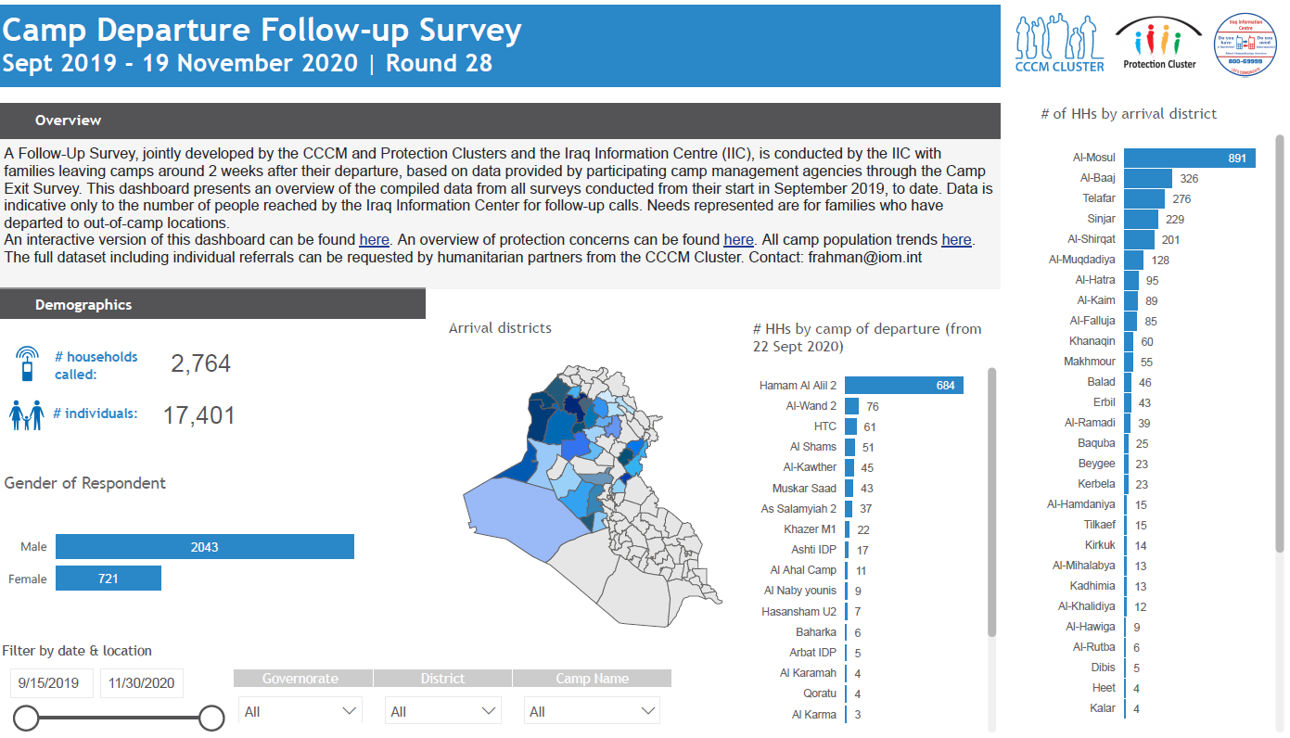**Full dashboard**, produced by CCCM Cluster, hosted on CCCM Cluster website (cumulative data since start of Survey)
      * [Interactive Dashboard](https://app.powerbi.com/view?r=eyJrIjoiYjgzMjU2ZjMtNDlhNi00MjYyLWEwY2ItYWM1YzI4NjY4MDdmIiwidCI6ImU1YzM3OTgxLTY2NjQtNDEzNC04YTBjLTY1NDNkMmFmODBiZSIsImMiOjh9)
      * [PDF](https://data.unhcr.org/en/documents/details/90053)
   2. 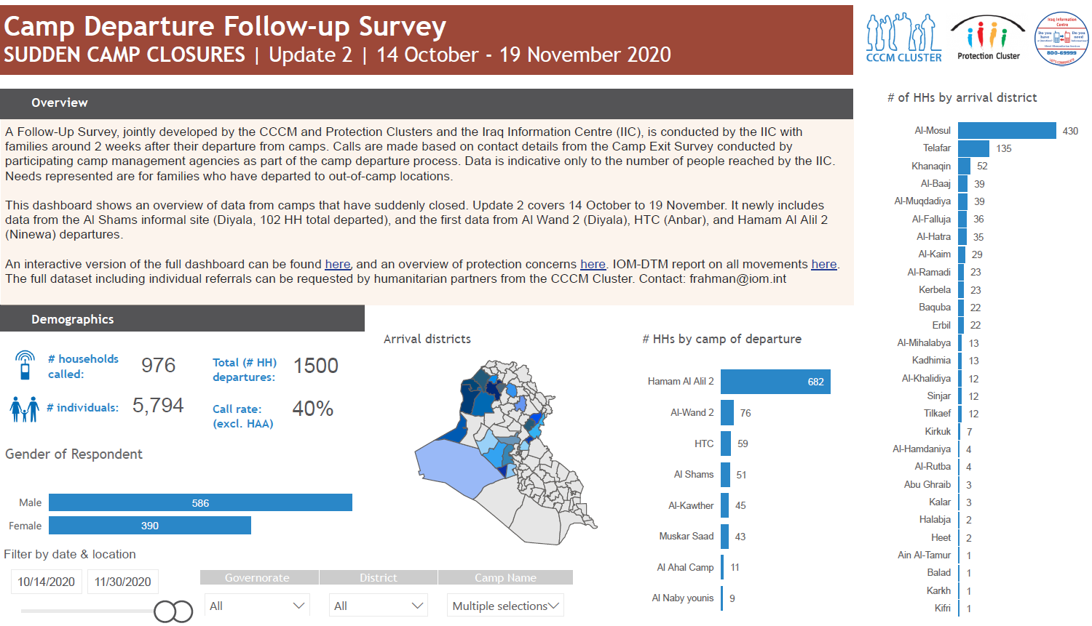**Camp Closure Dashboard** produced by CCCM Cluster, hosted on CCCM Cluster website (data from camp closures only, to inform closure response)
      * [Interactive dashboard](https://app.powerbi.com/view?r=eyJrIjoiYzY4ODIyMmMtYmFlNy00NzAzLTk2YjMtNTg5N2QwZjI1OTZkIiwidCI6ImU1YzM3OTgxLTY2NjQtNDEzNC04YTBjLTY1NDNkMmFmODBiZSIsImMiOjh9)
      * [PDF](https://data.unhcr.org/en/documents/details/90052)
   3. **Protection dashboard**, [interactive](https://app.powerbi.com/view?r=eyJrIjoiYmVmODUzOWMtYjk2OS00MmYzLThjODctMGZlYTdlOWYwNzI1IiwidCI6ImU1YzM3OTgxLTY2NjQtNDEzNC04YTBjLTY1NDNkMmFmODBiZSIsImMiOjh9),produced by the Protection Cluster with just protection-related data, hosted on Protection Cluster website
2. **Datasets** [limited circulation]
   1. 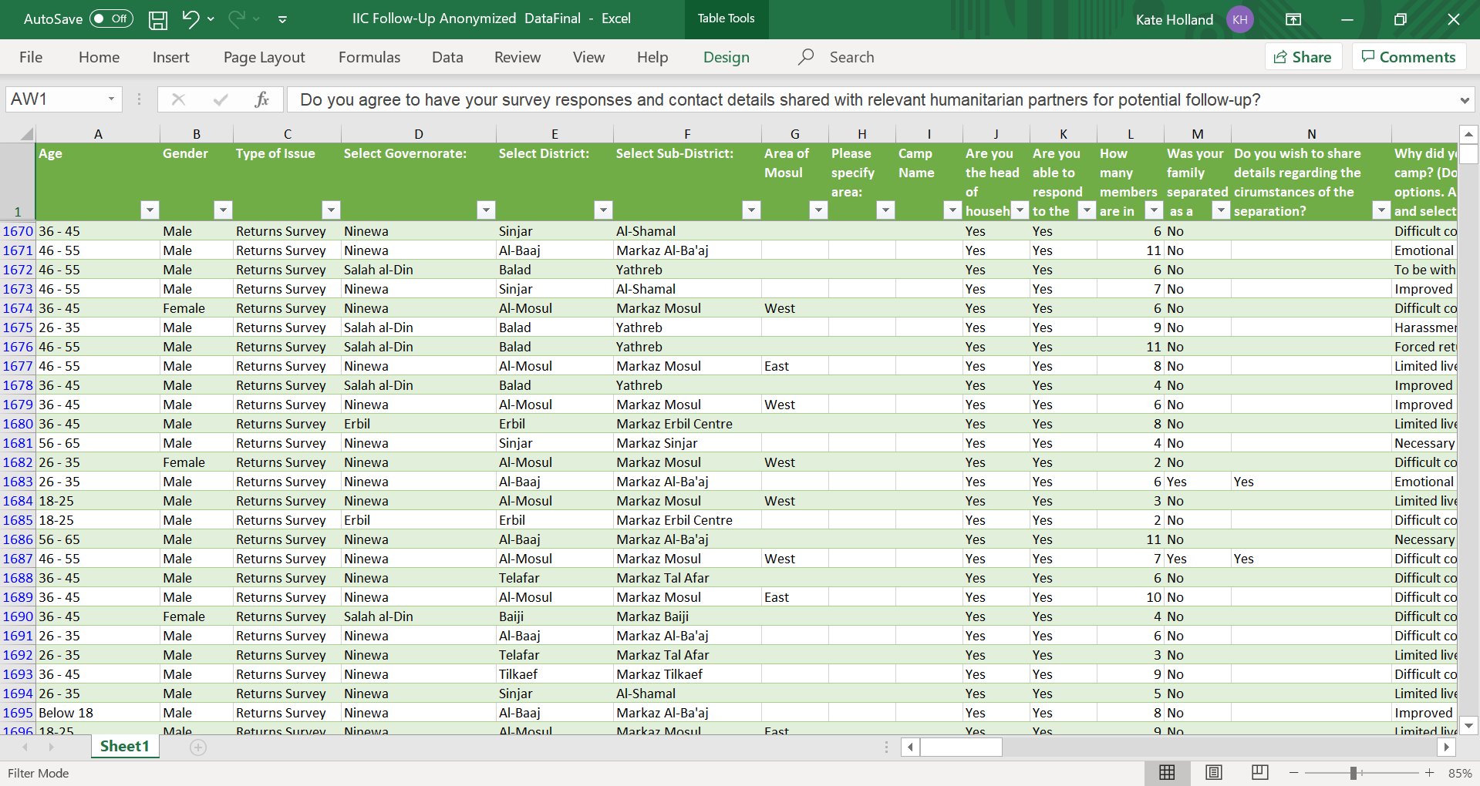**Anonymised dataset** to inform location-level response planning [circulated by CCCM Cluster to Clusters & ICCG at national and governorate level]
   2. **Referrals dataset** – individual household data & contact details by location, for program intake [humanitarian actor request to CCCM Cluster, for specific locations]

**Limitations & considerations**

* Low uptake even during camp closures of data for referrals – from Clusters & from partners
* Ethical considerations to continue if data not being used
* Questions posed to other Clusters & partners:
  + Is the data being used by Clusters for analysis?
  + Is the data being used by partners for referrals? If not, why not?
* Options discussed internally with CCCM Cluster & with other stakeholders:
  + Sample for ongoing data collection?
  + Trigger for large population movements?
* Given low use, the decision was made to stop the Survey after the last round of Camp Closure data collection in February 2021, with theoretical capacity for it to be triggered for future large population movements from camps